CHAPTER 1
INTRODUCTION

1.1 Overview
Artificial Intelligence has taken center stage in many contemporary digital platforms because they can provide smart solutions and offer personalization. With regards to the development of an intelligent solution for interviews preparation, the existing approaches are still far from ideal and cannot be used to adequately prepare people for real interviews. They have little flexibility and do not account for differences in the user's performance level.
SkillRoute AI tries to fill this gap by creating an adaptive learning platform that will change its behavior according to the user's input. The algorithm used will not follow a pre-set set of questions but will respond to the user's answers and change the direction of the interaction depending on the user's replies.
The system uses not only voice analysis but also language and behavior to understand the user's performance better. Thus, the platform offers a realistic scenario where one can practice both their skills and communication.
In general, the developed platform can be considered as a step towards moving away from the outdated static solutions to more intelligent systems..
1.2 Motivation
One of the main issues affecting the current generation of students and those in search of jobs is the difference between theoretical knowledge and practical interviewing skills. Even though many people have a lot of knowledge, they often find themselves incapable of answering questions adequately, thinking properly under stress, and keeping their confidence levels high. This does not happen because of any deficiency in knowledge; rather, this happens due to the fact that people do not have enough training on how to act during a conversation in a real environment.
Current interview preparation applications cannot provide adequate help since they are all based on standard sets of questions and offer the same experience to everyone. They also ignore the behavioral component of an effective interview: users cannot see how long it took for them to answer questions or how confident they were in their statements. Therefore, the idea behind SkillRoute AI is that users should get a product that could learn about them.
By leveraging artificial intelligence and adaptive decision-making, the system aims to transform interview preparation into a guided and interactive process rather than a static practice activity.
  - Problem Definition
Though there are plenty of online interview preparations' websites, candidates have encountered various problems with interview simulation. The majority of systems are developed in accordance with a certain pattern – each user gets an identical set of predefined questions that remains the same regardless of user performance and progress. In other words, the process cannot be adaptive, which means that a learner receives a generic preparation experience without personal touchpoints.
Secondly, the lack of behavioral analysis is another serious problem. Most systems evaluate user's responses based on text only, neglecting the importance of hesitations, time required to make an answer, and other factors that influence the way users demonstrate themselves during a real interview. However, all these elements are essential to understand how efficient users will be.
Furthermore, the feedback provided by such services is rather ineffective since users get limited information about their strong and weak points. In general, the process does not deliver expected results because learners are not able to understand what skills should be improved to increase their chances to get hired.
As it follows from the above mentioned issues, there is a need for developing a more advanced and intelligent tool.
  - Proposed Solution
In order to overcome the weaknesses associated with current solutions, an innovative, advanced AI-based application named SkillRoute AI is offered as a means of revolutionizing the interview training process by incorporating a new approach in the process.
The solution allows for real-time interaction between the user and the application, as it analyzes the user's answers and makes decisions in real-time concerning the process of interviewing the individual.
The solution allows for processing audio data from the user as well as textual inputs, employing natural language processing and speech recognition technologies for the analysis of the provided information. Additionally, the solution also allows for assessing certain behavioral characteristics in the process, which include response time, hesitation points, and self-confidence measures.
A key part of the system includes an Adaptive Decision Engine component, which makes decisions regarding the next steps in the process based on the current evaluation of the performance of the user. Thus, the system can dynamically select the optimal next step in the conversation.
Finally, the feedback provided by the system also plays an important role in this regard.
  - Objectives of the Project
One of the main objectives of the proposed system is the creation of a highly personalized interview preparation platform. It will be able to adjust to the performance of each user and offer an experience tailored to his needs.
One of the objectives of the project is to perform comprehensive analysis of user responses, which includes linguistic and behavioral characteristics of answers. The system will be able to make conclusions about the quality of answers and the level of confidence of participants in the conversation.
The goal of the project is the creation of an adaptive decision-making algorithm, which is aimed at managing the interaction process and ensuring that the dialogue develops organically without following any pre-programmed scenario.
One of the goals is to create a platform that will give detailed feedback to users and help them improve their skills and boost their confidence in preparing for interviews.
In general, the objective of the work is the transition from the existing interview preparation model to an advanced intelligent interview preparation system.
1.6 Scope of the Project
The scope of the project includes the development of a web-based platform that supports interactive interview sessions. The system focuses on communication and interview skill development and can be extended to multiple domains such as technical interviews, HR interviews, and behavioral assessments.

1.7 Organization of the Report
The report is organized into the following chapters:
- Chapter 1: Introduction
- Chapter 2: Literature Survey
- Chapter 3: Problem Analysis
- Chapter 4: System Design
- Chapter 5: Implementation and Results
- Chapter 6: Conclusion
- Chapter 7: Future Scope
Each chapter provides a detailed explanation of different aspects of the proposed system.
1.8 Conclusion
This chapter presented the concept of SkillRoute AI and emphasized the necessity for an adaptive AI-driven interview mentorship system. It also addressed the limitations of current systems and explained the rationale behind the proposed solution. Subsequent chapters will delve deeper into the system, covering the literature review, design, implementation, and evaluation phases.

CHAPTER 2
LITERATURE SURVEY

2.1 Introduction
The development of the field of Artificial Intelligence and Machine Learning has led to changes in the design of educational and training systems. Platforms now develop into intelligent systems that would be able to analyze the behavior of users and provide tailored learning opportunities. As for interview preparation, this becomes especially relevant because of the inability of current techniques to reflect the complexity of the process.
Thus, this chapter will provide analysis of existing solutions associated with interview preparation systems, conversational AI, speech processing, and intelligent tutoring systems. It will also identify the problems associated with the application of these technologies and show why a new technology is needed.
2.2 AI-Based Interview Preparation Systems
A number of websites are created to help people in preparing for an interview. Candidates are provided with practice questions, mock interviews, or even some information concerning frequently asked questions and sample answers.
Mostly, platforms operate according to a similar algorithm when offering their services. Candidates are offered a predetermined set of questions without considering any differences in the performance of users. The lack of personalization is the major problem here.
In addition, some interview preparation systems make use of artificial intelligence to evaluate the performance of interviewees. However, their algorithms
2.3 Conversational AI and Chatbots
The reason for their widespread adoption is due to their ability to communicate with humans in a natural way. Many conversational technologies have been adopted in applications like customer service, learning, and training.
These applications make use of natural language processing algorithms that allow them to conduct conversations in a natural fashion. They may be helpful in simulating interviews because they can conduct conversations based on Q&A sessions. However, most chatbot applications follow predefined flows and do not provide dynamic adaptability.
This means that without an efficient decision-making process, chatbot systems cannot adjust according to different user inputs and change the difficulty of the conversation accordingly.
2.4 Speech Analysis Systems
The developments in the field of speech processing have been able to allow systems to translate voice into text accurately. Apart from transcription, today’s speech analysis methods have also been able to identify useful information, which include the rate of speech, pause periods, and hesitations, among others.
This information is vital as a reflection of one’s communication skills. But unfortunately, most applications today employ speech processing technology merely for transcription or pronunciation improvement, and not in terms of assessing one’s performance in an interview setting.
2.5 Intelligent Tutoring Systems
Intelligent tutoring systems aim to offer customized learning experiences where information is tailored according to user performance. These kinds of systems are commonly used in educational setups for helping students learn difficult topics.
Even though intelligent tutoring systems are effective in delivering knowledge-based information, they have limited use when it comes to preparing candidates for interviews. The reason behind this is that the system is concerned only with accuracy and does not address communicative skills or behavior of the users.
2.6 Limitations of Existing Systems
However, based on the evaluation of different methodologies, there are several limitations. First, most of them do not include real-time adaptation of the algorithm in relation to the users' performance. Moreover, they cannot take into account behavioral aspects such as confidence, hesitation, or reaction time.
One more disadvantage is the use of pre-set questions, which lowers the level of realism of the process. The third aspect concerns the quality of the feedback; it is quite poor and provides no instructions for improvement.
These problems indicate that the current solutions are insufficient for interview preparation.

2.7 Research Gap
From the review of existing systems, it can be seen that there is no integration among the various technologies used for conversation with AI. There is no system that includes both analysis of behavior and dynamic decision-making together.
Such a system will allow providing a solution that supports adaptation and interaction at the same time.
2.8 Proposed Approach
Through the incorporation of several technologies in one application, the proposed technology seeks to rectify these shortcomings. The application will utilize speech recognition, natural language understanding, as well as adaptive decision making, in order to make the process more interactive.
It will analyze not only the response, but also the manner of its presentation, thus being able to give a more relevant feedback. Through the modification of the process flow depending on the performance level, it becomes possible to make each interaction unique.
This helps in the creation of a more authentic environment for the interview.
2.9 Conclusion
This chapter examined different existing systems regarding interview preparation and evaluated their advantages and drawbacks. It is evident from the analysis that the current systems are inflexible and are unable to leverage behavioral analysis.
The research gap established above provides the basis for the proposed system. The objective of the system is to offer enhanced interview preparation capabilities. The following chapter highlights an in-depth examination of the problem and its justification.

CHAPTER 3
PROBLEM ANALYSIS

3.1 Introduction
Interview preparation is an essential task for any aspiring student or professional, and its importance is evident from the fact that the results can determine whether one will be employed. Apart from having sufficient knowledge, the key requirements to succeed include strong communication skills, high self-confidence, and the capacity to reason and react swiftly to questions. The reasons why most students fail to secure jobs through interviews are not due to insufficient knowledge but inability to articulate themselves during the process.
While there are many sites offering tips for interview preparation, none of them simulates actual interview circumstances.
3.2 Existing System
Today’s existing systems for preparing interviews typically contain commonly asked questions along with practice rounds. The users can answer those questions, and they may even get some feedback on that.
Unfortunately, most such tools work in the same way in which the order of the questions remains the same for all users. All of them will have the same experience, irrespective of their proficiency levels.
The more sophisticated programs might have AI analysis in them. But this is limited to only text-based answers, and there’s no provision to check the delivery part of the answer.
3.3 Limitations of Existing System
One of the problems with the existing systems is that they cannot be adjusted in a real-time fashion. Given that the process of asking the questions is predetermined, the user does not get to engage in the dynamic interaction experienced during the interviews.
Another critical problem with the system is that it does not provide any kind of behavioral analysis. Things like hesitation, reaction time, and level of confidence affect the success of an interview to a large extent, but the systems ignore those.
The existing solutions also fail to personalize the experience offered to each user. In other words, no matter how the person performed, they will still have the same kinds of questions and feedback given.
Furthermore, the interaction pattern offered by these tools is very rigid because it follows the set course without offering any flexibility. The user cannot experience something resembling a real-life interview, which is quite natural.
Lastly, the systems do not offer very deep feedback to their users.
3.4 Need for the Proposed System
It is evident from the limitations in the current systems that there is a need for an improved method of preparing for interviews. A system must be developed that can modify its behavior according to the response of the user.
The ability to analyze not only the content but also the delivery of the response is necessary. The ability to create conditions similar to those of a real interview and change the dynamics of the conversation is also important.
Lastly, the provision of constructive feedback is essential in such a system. This will enable users to know where they excel and areas that need improvement.
3.5 Proposed System Overview
SkillRoute AI system is conceived to offer an adaptive interview experience on-the-go. The answers provided by the users can be captured either as voice or text and processed using sophisticated technology.
It analyses both language as well as behavior of the answer provided by the user and accordingly decides the course for proceeding with the interview. Thus, each user gets a unique path in the interview process.
Adaptive Decision Engine will play a key role in deciding the follow-up questions as well as the level of difficulty.
3.6 Advantages of Proposed System
In comparison with the existing models, the proposed approach is characterized by a number of advantages. First, there is real-time adaptability in order to make the interaction dependent on user performance. As a result, the learning process becomes much more efficient.
Second, behavioral analysis is used in the system. Thus, such characteristics as hesitancy and confidence will be considered when assessing the communicative abilities of a user.
Third, personalization is also present in this type of software, which means that each user gets an individual experience. Fourth, conversation will create a more realistic interview atmosphere.
All these benefits make the system quite effective for learning purposes.
3.7 Feasibility Study
On the other hand, economically, the implementation of this system is feasible due to its use of affordable cloud services and open-source software.
Finally, operation-wise, the design of this system is easy and user-friendly for the users.
3.8 Conclusion
In this chapter, the problems related to existing interview preparation systems have been identified, and the limitations of such systems have been discussed. Moreover, the need for an adaptive and personalized interaction has been highlighted.
The solution that has been offered is based on the concepts of behavioral analysis, decision-making and dynamic conversation and will be covered in detail in the next chapter.
It is possible to develop the suggested system from different perspectives. From a technological viewpoint, the needed technology like AI, speech processing and cloud computing is available and easy to integrate.

CHAPTER 4
SYSTEM DESIGN

4.1 Introduction
This chapter outlines the architecture and framework of the proposed SkillRoute AI system. The system was designed with the intention of facilitating real-time engagement through an integration of various modules including voice analysis, behavior assessment, decision making, and conversation intelligence. It does not work as a standalone solution but uses a modular approach whereby each module performs its own task while engaging with other modules.
4.2 System Architecture
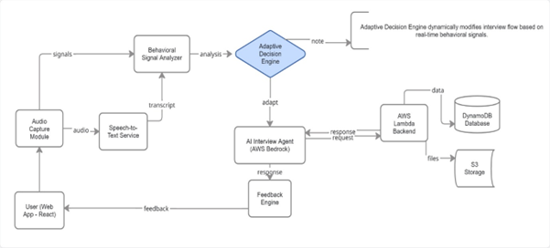
The system architecture comprises different levels designed to enhance smooth performance and scalability.
The first level of architecture entails the user interaction level. This is the point where the user interacts with the system through an interface. The interface facilitates participation in the interviews and submission of answers in either audio or textual formats.
The second level of architecture entails the process and intelligence level. This level deals with all major processes such as conversion of voice input to text, analysis of behavior, and response generation.
The last level entails cloud infrastructure, which enhances storage, processing, and integration of AI technology.

Data Models
User Profile Schema
{
"college_email": "student@college.com",
"password_hash": "salt:hash",
"full_name": "John Doe",
"user_type": "free|premium",
"personal_info": {
"username": "john_doe",
"gender": "male",
"age": 20,
"date_of_birth": "2005-06-15"
},
"academic_info": {
"college_name": "MITS",
"program": "B.Tech",
"branch": "Computer Science",
"year": 3,
"sem": 6
},
"usage_info": {
"communication_tests": {
"jam_test": 3,
"pronu_test": 2,
"listen_test": 2,
"situation_test": 2
},
"communication_practices": {
"jam_practice": 10,
"pronu_practice": 10,
"listen_practice": 10,
"situation_practice": 10
},
"basic_interview_tests": {
"self_introduction_test": 3
},
"basic_interview_practices": {
"self_introduction_practice": 10
}
},
"payment_details": {
"provider": "razorpay",
"plan": "monthly",
"start_date": "2025-01-15",
"expiry_date": "2025-02-15",
"payment_id": "pay_xxx",
"order_id": "order_xxx",
"amount": 9900,
"status": "success"
},
"streak": {
"current_streak": 5,
"longest_streak": 12,
"last_active_date": "2025-01-15",
"active_dates": ["2025-01-11", "2025-01-12", "2025-01-13", "2025-01-14", "2025-01-15"]
}
}
Session Data Schema
{
"sessionId": "jam-test-basic-1234567",
"college_email": "student@college.com",
"test_type": "jam",
"level": "basic",
"mode": "test|practice",
"start_time": "2025-01-15T10:30:00Z",
"end_time": "2025-01-15T10:45:00Z",
"conversation_history": [
{
"role": "user|ai",
"content": "message content",
"timestamp": 1705312200000
}
],
"final_score": 8.5,
"ai_feedback": "Detailed assessment report...",
"audio_recordings": [
{
"recording_id": "jam-test-basic-1234567-stt-1",
"s3_url": "https://bucket.s3.region.amazonaws.com/audio.wav",
"transcript": "transcribed text",
"duration": 45
}
]
}
4.3 System Workflow
The working process of the system starts from the initiation of the interview by the user. First, the system uses the AI module to generate a question for the user and display it to him/her. The user answers the question, and his/her answer undergoes processing.
In case the answer was provided in an audio format, the text equivalent of the message will be formed first. Then, both the content and presentation of the answer will be analyzed. Depending on the result, the system analyzes the user's performance and further action will be decided.
The next question is chosen automatically, and the interview continues dynamically depending on the user's answers. Feedback is created constantly during the interview process.
4.4 Module Description
The system consists of various modules that serve different purposes. The audio capturing module captures audio input from users whereas the text creation module converts this input from speech to text. Behavioral analysis looks at characteristics like pausing, response time, and hesitation before making a judgment on the quality of the communication.
The information is forwarded to the decision-making component that makes decisions about how the rest of the interview will be conducted. The AI interview agent acts as a question generator to ensure that the interview flows well.
The feedback module performs performance evaluations and shows areas that need improvement.
4.5 Data Flow
The data flow in the system is continuous and repetitive. Input from the user is processed by the system, and the output obtained from the processing is used for determining what the next action in the conversation will be.
This cycle continues during the entire session to make sure that the system remains dynamic and interactive.
4.6 Algorithm Design
The algorithm that runs this system is a repetitive one. It involves the generation of a question from the system and the collection of input provided by the user in response to the question. The input is then processed, and the results of the processing are evaluated on the basis of their linguistic and behavioral nature.
The next action taken by the system depends upon the results of the evaluation.
4.7 Design Considerations
Several factors were considered while designing the system. Scalability is an important aspect, as the system should be able to handle multiple users simultaneously. Real-time processing is also essential to maintain smooth interaction.
The design focuses on modularity, allowing individual components to be updated or improved without affecting the entire system. In addition, the interface is designed to be simple and user-friendly, ensuring ease of use.
4.8 Benefits of System Design
Some of the benefits of this system include real-time flexibility and fast processing of data. Its modular architecture makes the system very adaptable and easy to maintain, whereas its reliance on cloud computing services allows for scalability.
The incorporation of behavioral analysis into the decision-making process will improve the efficiency of the application's functioning. In addition, users will have a more personalized experience that will help them learn and develop their skills.
4.9 Explanation of the System Architecture
This system has a cloud-based architecture. It enables real-time communication and scalability. The frontend part of the application includes the UI of the application where the user interacts with it.
The requests made by users via the UI are processed by the API layer. This layer sends requests further to backend services, which in turn communicate with AI models and make decisions based on them.
User data, performance metrics, and session information are stored in the cloud storages. In addition, there are specialized storages where the audio data is kept for processing.
There is a separate media processing layer responsible for tasks such as speech-to-text transcription and processing of audio files. Besides, other services are available for
4.10 Conclusion
This chapter described the overall design and architecture of SkillRoute AI. The modular approach and adaptive decision-making enable the system to provide real-time personalized interaction. The next chapter will focus on implementation details and system results.

CHAPTER 5
IMPLEMENTATION AND RESULTS

5.1 Introduction
This chapter will describe the way in which SkillRoute AI is implemented and operates in various scenarios. The implementation relies on building a system that will be able to operate in real-time and respond promptly to input from users, and provide valuable feedback. It involves the use of frontend programming techniques, backend services, cloud services and AI that allow for the operation of an interview platform.
5.2 Development Environment
Development of the system relies on the implementation of several contemporary technologies which enable scalability and efficient functioning of SkillRoute AI. Web frontend technologies including React, HTML and CSS are used to develop the interactive interface for the platform.
In terms of backend development, server-side scripting languages and serverless architectures are used. Cloud services play a crucial role, helping with management of data storage and analysis. They are involved in handling API requests, user data, and audio input data.MAIN PAGES
import React, { Suspense, lazy, useEffect } from "react";
import { BrowserRouter as Router, Routes, Route, Navigate } from "react-router-dom";
// Basic Components
import LoadingSpinner from "./basic_components/LoadingSpinner.jsx";
import ScrollToTop from "./basic_components/ScrollToTop.jsx";
import Layout from "./components/Layout.jsx";

// Landing page components
const LandingPage = lazy(() => import("./LandingPageFiles/LandingPage.jsx"));

// Registration components
const Signup = lazy(() => import("./RegisterFiles/Signup.jsx"));
const ProfileData = lazy(() => import("./components/ProfileData.jsx"));
const PaymentPlans = lazy(() => import("./components/PaymentPlans.jsx"));
const ProfileCreation_Survey = lazy(() => import("./RegisterFiles/ProfileCreation/ProfileCreation.jsx"));

// Pratice Components
const Practice = lazy(() => import("./CommunicationPraticeFiles/Practice.jsx"))

// Test Components
const Test = lazy(() => import("./CommunicationTestsFiles/Test.jsx"));
const JAM1 = lazy(() => import("./CommunicationTestsFiles/JAM.jsx"))
const Pronunciation1 = lazy(() => import("./CommunicationTestsFiles/Pronunciation.jsx"));
const Listening = lazy(() => import("./CommunicationTestsFiles/Listening.jsx"));
const SituationSpeak = lazy(() => import("./CommunicationTestsFiles/SituationSpeak.jsx"));
const TestFeedbackPage = lazy(() => import("./CommunicationTestsFiles/TestFeedbackPage.jsx"));

// Interview Components
const Interview = lazy(() => import("./InterviewModule/Interview.jsx"));
const InterviewPracticeHub = lazy(() => import("./InterviewModule/InterviewPracticeFiles/InterviewPracticeHub.jsx"));
const InterviewTestHub = lazy(() => import("./InterviewModule/InterviewTestFiles/InterviewTestHub.jsx"));
const InterviewPracticeSession = lazy(() => import("./InterviewModule/InterviewPracticeFiles/InterviewPracticeSession.jsx"));
const InterviewPracticeFeedbackPage = lazy(() => import("./InterviewModule/InterviewPracticeFiles/InterviewPracticeFeedbackPage.jsx"));
const InterviewTestSession = lazy(() => import("./InterviewModule/InterviewTestFiles/InterviewTestSession.jsx"));
const InterviewTestFeedbackPage = lazy(() => import("./InterviewModule/InterviewTestFiles/InterviewTestFeedbackPage.jsx"));

// Practice Components - Base
const BaseComponentPractice = lazy(() => import("./CommunicationPraticeFiles/BaseComponentPractice.jsx"));
const PracticeFeedbackPage = lazy(() => import("./CommunicationPraticeFiles/PracticeFeedbackPage.jsx"));

// Student Dashboard and Leaderboard files
const Dashboard = lazy(() => import("./Dashboard_LeaderboardFiles/Dashboard.jsx"));
const JAMDashboard = lazy(() => import("./Dashboard_LeaderboardFiles/JAMDashboard.jsx"));
const SituationSpeakDashboard = lazy(() => import("./Dashboard_LeaderboardFiles/SituationSpeakDashboard.jsx"));
const ListeningDashboard = lazy(() => import("./Dashboard_LeaderboardFiles/ListeningDashboard.jsx"));
const PronunciationDashboard = lazy(() => import("./Dashboard_LeaderboardFiles/PronunciationDashboard.jsx"));
const Leaderboard = lazy(() => import("./Dashboard_LeaderboardFiles/Leaderboard.jsx"))
const BasicInterviewDashboard = lazy(() => import("./Dashboard_LeaderboardFiles/BasicInterviewDashboard.jsx"));
const AdvancedInterviewDashboard = lazy(() => import("./Dashboard_LeaderboardFiles/AdvancedInterviewDashboard.jsx"));
const MainLayout = ({ children }) => (
<>
<main className="main-content">
<Suspense fallback={<LoadingSpinner />}>
{children}
</Suspense>
</main>
</>
);

// Auth layout is not needed as Login/Signup components handle their own layout
const AuthLayout = ({ children }) => (
<Suspense fallback={<LoadingSpinner />}>
{children}
</Suspense>
);

const DashboardLayout = ({ children }) => (
<>
{/* <Login_Navbar /> */}
<main className="dashboard-content">
<Suspense fallback={<LoadingSpinner />}>
{children}
</Suspense>
</main>
</>
);

const CommunicationPraticeLayout = ({ children }) => (
<>
<main className="dashboard-content">
<Suspense fallback={<LoadingSpinner />}>
{children}
</Suspense>
</main>
</>
);

// Auth guard - redirects to login if not authenticated
const ProtectedRoute = ({ children }) => {
const isAuthenticated = localStorage.getItem("email");
return isAuthenticated ? children : <Navigate to="/signup" />;
};

// Protected Layout for authenticated routes
const ProtectedLayout = () => {
const isAuthenticated = localStorage.getItem("email");
return isAuthenticated ? <Layout /> : <Navigate to="/signup" />;
};

// Reset global styles when navigating between routes
const RouteChangeHandler = () => {
useEffect(() => {
// Reset body styles to default
document.body.style = "";
document.body.className = "";

return () => {
// Cleanup if needed
};
}, []);

return null;
};

function ErrorBoundary({ children }) {
// Minimal client-side error boundary
const [error, setError] = React.useState(null);
React.useEffect(() => {
if (error) console.error('ErrorBoundary caught:', error);
}, [error]);
if (error) {
return (
<div style={{ padding: 24 }}>
<h2>Something went wrong rendering the app.</h2>
<pre style={{ whiteSpace: 'pre-wrap' }}>{String(error && error.stack ? error.stack : error)}</pre>
</div>
);
}
try {
return children;
} catch (e) {
setError(e);
return null;
}
}

function App() {
return (
<Router>
<RouteChangeHandler />
<ScrollToTop />
<ErrorBoundary>
<Suspense fallback={<LoadingSpinner />}>
<Routes>
{/* Public routes */}
<Route path="/" element={
<MainLayout>
<LandingPage />
</MainLayout>
} />

{/* Auth routes */}
<Route path="/signup" element={
<AuthLayout>
<Signup />
</AuthLayout>
} />

<Route path="/profile-creation-survey" element={
<AuthLayout>
<ProfileCreation_Survey />
</AuthLayout>
} />

{/* Protected routes with Layout */}
<Route path="/" element={<ProtectedLayout />}>
<Route path="profiledata" element={<ProfileData />} />
<Route path="payment-plans" element={<PaymentPlans />} />
<Route path="practice" element={<Practice />} />
<Route path="test" element={<Test />} />
<Route path="student-dashboard" element={<Dashboard />} />

<Route path="student-leaderboard" element={<Leaderboard />} />
</Route>

{/* Communication test routes without header */}
{/*
<Route path="student-dashboard/jam" element={<JAMDashboard />} />
<Route path="student-dashboard/situationspeak" element={<SituationSpeakDashboard />} />
<Route path="student-dashboard/listening" element={<ListeningDashboard />} />
<Route path="student-dashboard/pronunciation" element={<PronunciationDashboard />} /> */}

<Route path="student-dashboard/jam" element={
<ProtectedRoute>
<JAMDashboard />
</ProtectedRoute>
} />

<Route path="student-dashboard/situationspeak" element={
<ProtectedRoute>
<SituationSpeakDashboard />
</ProtectedRoute>
} />

<Route path="student-dashboard/listening" element={
<ProtectedRoute>
<ListeningDashboard />
</ProtectedRoute>
}/>

<Route path="student-dashboard/pronunciation" element={
<ProtectedRoute>
<PronunciationDashboard />
</ProtectedRoute>
}/>
<Route path="student-dashboard/interview-basic" element={
<ProtectedRoute>
<BasicInterviewDashboard />
</ProtectedRoute>
}/>
<Route path="student-dashboard/interview-advanced" element={
<ProtectedRoute>
<AdvancedInterviewDashboard />
</ProtectedRoute>
}/>

<Route path="test/jam" element={
<ProtectedRoute>
<JAM1 />
</ProtectedRoute>
} />
<Route path="test/pronunciation" element={
<ProtectedRoute>
<Pronunciation1 />
</ProtectedRoute>
} />
<Route path="test/listening" element={
<ProtectedRoute>
<Listening />
</ProtectedRoute>
} />
<Route path="test/situation-speak" element={
<ProtectedRoute>
<SituationSpeak />
</ProtectedRoute>
} />
<Route path="test/feedback" element={
<ProtectedRoute>
<TestFeedbackPage />
</ProtectedRoute>
} />

{/* Communication practice routes */}
<Route path="practice/jam" element={
<ProtectedRoute>
<BaseComponentPractice
practiceType="jam_practice"
practiceTitle="JAM Practice"
practiceDescription="JAM speaking sessions to improve spontaneous communication"
/>
</ProtectedRoute>
} />
<Route path="practice/pronunciation" element={
<ProtectedRoute>
<BaseComponentPractice
practiceType="pronu_practice"
practiceTitle="Pronunciation Practice"
practiceDescription="Perfect your pronunciation with AI-powered feedback"
/>
</ProtectedRoute>
} />
<Route path="practice/listening" element={
<ProtectedRoute>
<BaseComponentPractice
practiceType="listen_practice"
practiceTitle="Listening Practice"
practiceDescription="Enhance comprehension with interactive listening exercises"
/>
</ProtectedRoute>
} />
<Route path="practice/situation" element={
<ProtectedRoute>
<BaseComponentPractice
practiceType="situation_practice"
practiceTitle="Situational Speaking Practice"
practiceDescription="Practice real-life scenarios to build confidence"
/>
</ProtectedRoute>
} />
<Route path="practice/image-speak" element={
<ProtectedRoute>
<BaseComponentPractice
practiceType="image_speak_practice"
practiceTitle="Image-Based Speaking Practice"
practiceDescription="Describe images to enhance vocabulary and fluency"
/>
</ProtectedRoute>
} />
<Route path="practice/feedback" element={
<ProtectedRoute>
<PracticeFeedbackPage />
</ProtectedRoute>
} />

{/* Interview routes */}
<Route path="interview" element={
<ProtectedRoute>
<Interview />
</ProtectedRoute>
} />
<Route path="interview/practice" element={
<ProtectedRoute>
<InterviewPracticeHub />
</ProtectedRoute>
} />
<Route path="interview/practice/session" element={
<ProtectedRoute>
<InterviewPracticeSession />
</ProtectedRoute>
} />
<Route path="interview/practice/feedback" element={
<ProtectedRoute>
<InterviewPracticeFeedbackPage />
</ProtectedRoute>
} />
<Route path="interview/test" element={
<ProtectedRoute>
<InterviewTestHub />
</ProtectedRoute>
} />
<Route path="interview/test/session" element={
<ProtectedRoute>
<InterviewTestSession />
</ProtectedRoute>
} />
<Route path="interview/test/feedback" element={
<ProtectedRoute>
<InterviewTestFeedbackPage />
</ProtectedRoute>
} />

{/* Fallback routes */}
<Route path="/not-found" element={
<MainLayout>
<h1>Page Not Found</h1>
<p>The page you are looking for does not exist.</p>
</MainLayout>
} />
<Route path="*" element={<Navigate to="/" replace />} />
</Routes>
</Suspense>
</ErrorBoundary>
</Router>
);
}

export default App;
5.3 System Implementation
The system implementation itself is subdivided into several components depending on their functionality. Frontend enables communication between the user and the program. With it, the user starts new sessions, responds to prompts, and gets feedback.
Backend works in accordance with user commands and interacts with AI models. This guarantees the system’s ability to analyze responses and produce proper results.
AI also plays an important role here since it helps create a dialog and adapt its dynamics according to the user’s actions. In this case, the sequence of events is not static but rather dynamic.
Voice recognition is used to transcribe voice responses into plain text. Text analysis is complemented by analyzing behavior patterns including pausing and reaction time.
Finally, all of this information is analyzed in the decision-making step.

5.4 Database Design
The cloud database will be used by the system to store all the required data such as user's information, sessions data and performance. The stored data will be presented in a well structured form in order to ensure ease of access and manipulation.
Audio files will be stored separately from the database in order to facilitate separate processing of the media data.
5.5 Results and Output
Testing was done using several users to observe the performance and behavior of the system. Users could interact with the system and get immediate feedback right after every response.
The system could generate dynamic questions and adjust the conversation according to the responses provided by users. Users received performance score and recommendations in the feedback provided by the system.
All these show that the system provides a good learning experience.
5.6 Screenshots
This section provides the screen shots of the system interface and output screens. These will give a visual presentation of the interaction process carried out between the system and users in terms of starting sessions, giving responses and receiving feedback among others.

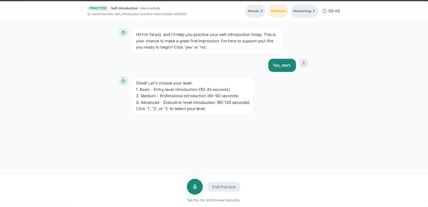
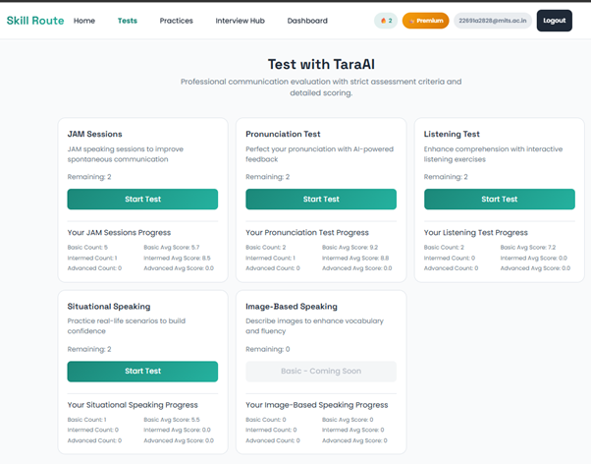
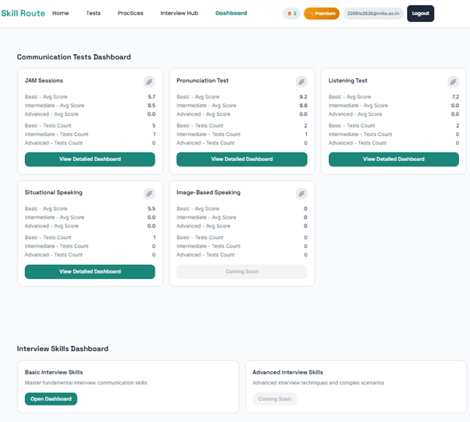
5.7 Benefits of Implementation
The proposed system has a number of advantages. First, it uses real-time processing that means that users get immediate feedback. Due to the use of cloud services, it is possible to work with many users at once.
Speech processing and artificial intelligence will lead to a better evaluation. Adaptive approach will contribute to the effectiveness of communication.
5.8 Drawbacks
There are some drawbacks of the system despite its high performance. First of all, the system needs the internet in order to function properly. Speech processing depends on the quality of audio recording.
Also, the performance of artificial intelligence models might need further adjustment in order to improve the outcomes of evaluations.
5.9 Implementation of Backend
The backend of the system has been implemented following the principle of serverless architecture where no servers are required to process the requests by the users.
Each functionality of the system is represented by separate services, which makes the system scalable.
In order to enable interactions between the frontend and backend, API services are implemented in order to make the processing more efficient.
Backend services use AI models for question generation and response evaluation. All user data is stored in a database.
MAIN CODES
"""
Bedrock client using Amazon Nova Lite (amazon.nova-lite-v1:0).
Nova API format:
Request: {"messages": [{"role": "user", "content": [{"text": "..."}]}],
"system": [{"text": "..."}],
"inferenceConfig": {"maxTokens": N, "temperature": 0.3}}
Response: {"output": {"message": {"content": [{"text": "..."}], "role": "assistant"}}}
"""
import json
import os
import time
import uuid
from decimal import Decimal
from typing import Any, Dict, List, Optional

import boto3
from botocore.exceptions import BotoCoreError, ClientError

class BedrockJSONError(Exception):
pass

def _json_default(obj: Any):
if isinstance(obj, Decimal):
# Preserve integers when possible, otherwise use float.
return int(obj) if obj % 1 == 0 else float(obj)
return str(obj)

def _client():
region = os.environ.get("BEDROCK_REGION", "us-east-1")
return boto3.client("bedrock-runtime", region_name=region)

def _invoke(messages: List[Dict], system: str = "") -> str:
model_id = os.environ.get("BEDROCK_MODEL_ID", "amazon.nova-lite-v1:0")

# Convert messages to Nova format: content must be array of {text: str}
nova_messages = []
for m in messages:
role = m.get("role")
if role not in ("user", "assistant"):
continue
content = m.get("content", "")
nova_messages.append({
"role": role,
"content": [{"text": str(content)}],
})

if not nova_messages:
raise BedrockJSONError("No messages to send")

body: Dict[str, Any] = {
"messages": nova_messages,
"inferenceConfig": {"maxTokens": 1024, "temperature": 0.3},
}
if system:
body["system"] = [{"text": system}]

resp = _client().invoke_model(
modelId=model_id,
body=json.dumps(body),
contentType="application/json",
accept="application/json",
)
raw = json.loads(resp["body"].read())
return raw["output"]["message"]["content"][0]["text"]

def _clean_json(text: str) -> str:
"""Strip markdown fences if model wraps JSON in ```json ... ```"""
text = text.strip()
if text.startswith("```"):
lines = text.split("\n")
# remove first and last fence lines
lines = [l for l in lines if not l.strip().startswith("```")]
text = "\n".join(lines).strip()
return text

def _structured(system: str, user: str, retries: int = 2) -> Dict[str, Any]:
last_err: Optional[Exception] = None
for attempt in range(retries + 1):
try:
raw = _invoke([{"role": "user", "content": user}], system=system)
return json.loads(_clean_json(raw))
except (json.JSONDecodeError, KeyError) as e:
last_err = e
time.sleep(0.5 * (attempt + 1))
except (BotoCoreError, ClientError) as e:
last_err = e
time.sleep(0.5 * (attempt + 1))
raise BedrockJSONError(f"Structured call failed after {retries+1} attempts: {last_err}")

# ── Public API ────────────────────────────────────────────────────────────────

def invoke_chat(
conversation: List[Dict[str, Any]],
onboarding: bool,
user_profile: Optional[Dict] = None,
) -> Dict[str, Any]:
"""
Returns {
"reply": str,
"user_type": str,
"actions": [{"title","description","cta","target","url"}],
"profile_update": dict | None
}
"""
if not os.environ.get("BEDROCK_MODEL_ID"):
# Offline stub
return {
"reply": "Hi! I'm your ET AI Concierge. Tell me about your profession and financial goals.",
"user_type": "New User",
"actions": [
{"title": "ET Markets", "description": "Live market data", "cta": "Explore", "target": "markets", "url": "https://economictimes.indiatimes.com/markets"},
{"title": "ET Prime", "description": "Expert analysis", "cta": "Try Free", "target": "prime", "url": "https://prime.economictimes.indiatimes.com"},
],
"profile_update": None,
}

system = _chat_system(onboarding, user_profile)
# Build message list for Nova (user/assistant only)
msgs = [
{"role": m["role"], "content": m.get("content", "")}
for m in conversation
if m.get("role") in ("user", "assistant")
]

raw = _invoke(msgs, system=system)
raw = _clean_json(raw)

try:
parsed = json.loads(raw)
except json.JSONDecodeError:
return {"reply": raw, "user_type": "User", "actions": [], "profile_update": None}

return {
"reply": parsed.get("reply") or parsed.get("response") or raw,
"user_type": parsed.get("user_type", "User"),
"actions": (parsed.get("actions") or [])[:3],
"profile_update": parsed.get("profile_update"),
}

def extract_profile(conversation: List[Dict[str, Any]]) -> Dict[str, Any]:
user_prompt = json.dumps({"conversation": conversation}, default=_json_default)
return _structured(_profile_system(), user_prompt)

def generate_recommendations(profile: Dict[str, Any]) -> Dict[str, Any]:
user_prompt = json.dumps({"profile": profile}, default=_json_default)
return _structured(_reco_system(), user_prompt)

def new_conversation_id() -> str:
return str(uuid.uuid4())

# ── Prompts ───────────────────────────────────────────────────────────────────

def _chat_system(onboarding: bool, profile: Optional[Dict]) -> str:
profile_ctx = f"\nKnown user profile: {json.dumps(profile, default=_json_default)}" if profile else ""

if onboarding:
mode_instructions = (
"\nMODE: ONBOARDING. Ask ONE question at a time to learn about the user. "
"Collect: profession (student/working/business), financial goals, experience level "
"(beginner/intermediate/advanced), income range, risk appetite. "
"After 3-4 exchanges, set profile_update with what you've learned. "
"Be warm, conversational, and encouraging."
)
else:
mode_instructions = (
"\nMODE: CONCIERGE. Use the user profile to give highly personalized guidance. "
"Recommend specific ET products and services. Guide them to relevant pages. "
"Be proactive about cross-sell opportunities."
)

return (
"You are the ET AI Concierge — a smart, friendly AI guide for the Economic Times ecosystem. "
"ET products you can recommend: ET Prime, ET Markets, ET Masterclasses, ET Wealth Summit, "
"ET Corporate Events, ET Financial Services (loans, insurance, credit cards, wealth management)."
+ profile_ctx
+ mode_instructions
+ "\n\nRESPOND WITH ONLY VALID JSON — no markdown, no extra text:\n"
'{"reply":"Your response (max 80 words, conversational)",'
'"user_type":"e.g. Beginner Investor / Growth Professional / Student Saver",'
'"actions":[{"title":"Page title","description":"One line desc","cta":"Button text","target":"page_key","url":"https://..."}],'
'"profile_update":{"profession":"...","financialGoals":["..."],"investmentExperience":"...","incomeRange":"...","riskAppetite":"..."} or null}\n'
"target values: markets, prime, masterclass, wealth_summit, corporate_events, financial_services, loans, insurance, credit_cards, wealth_management\n"
"Include 1-3 relevant actions. Only set profile_update when you have gathered enough info."
)

def _profile_system() -> str:
return (
"Extract a financial profile from the conversation. "
"Return ONLY valid JSON: "
'{"profession":"...","financialGoals":["..."],"investmentExperience":"beginner|intermediate|advanced",'
'"incomeRange":"...","riskAppetite":"low|moderate|high","etProductUsage":["..."],'
'"needs":["..."],"userType":"descriptive label like Growth-Focused Investor"}'
" — no extra text."
)

def _reco_system() -> str:
return (
"Given a user profile, return ONLY valid JSON: "
'{"recommendations":[{"title":"...","category":"...","description":"...","cta":"...","url":"...","relevanceScore":0.0-1.0}]} '
"with 4-8 items. Categories: ET Prime, ET Markets, Masterclasses, Wealth Summits, Corporate Events, "
"Financial Services, Loans, Insurance, Credit Cards, Wealth Management. "
"Make each recommendation specific to the user profile. No extra text."
)
5.10 Implementation of Frontend and its Architecture
The frontend has been created in order to allow for an interactive user experience. It consists of several components that are responsible for different functionalities.
These components make up the interface of the system where the user can interact with the application in order to use its features. User input triggers API request and the interface changes depending on the response returned from the backend.
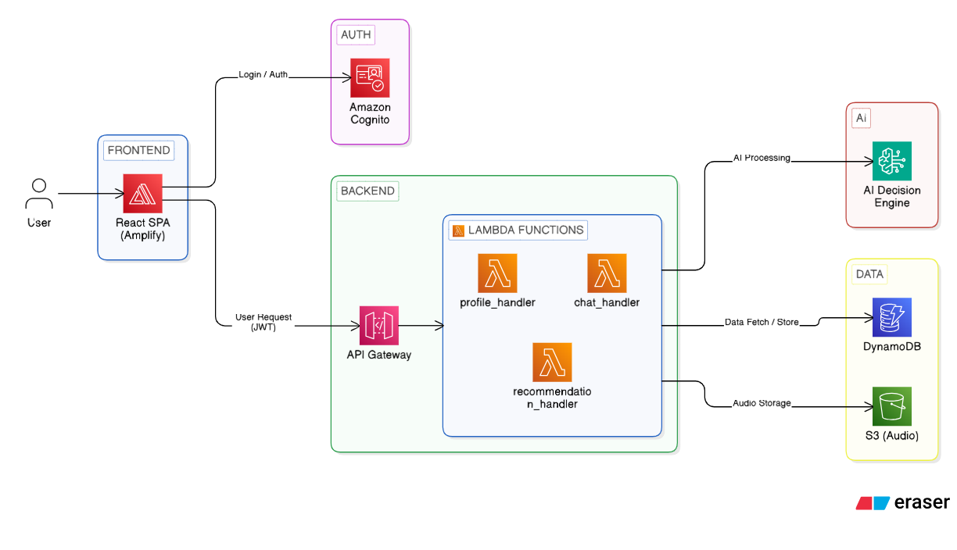

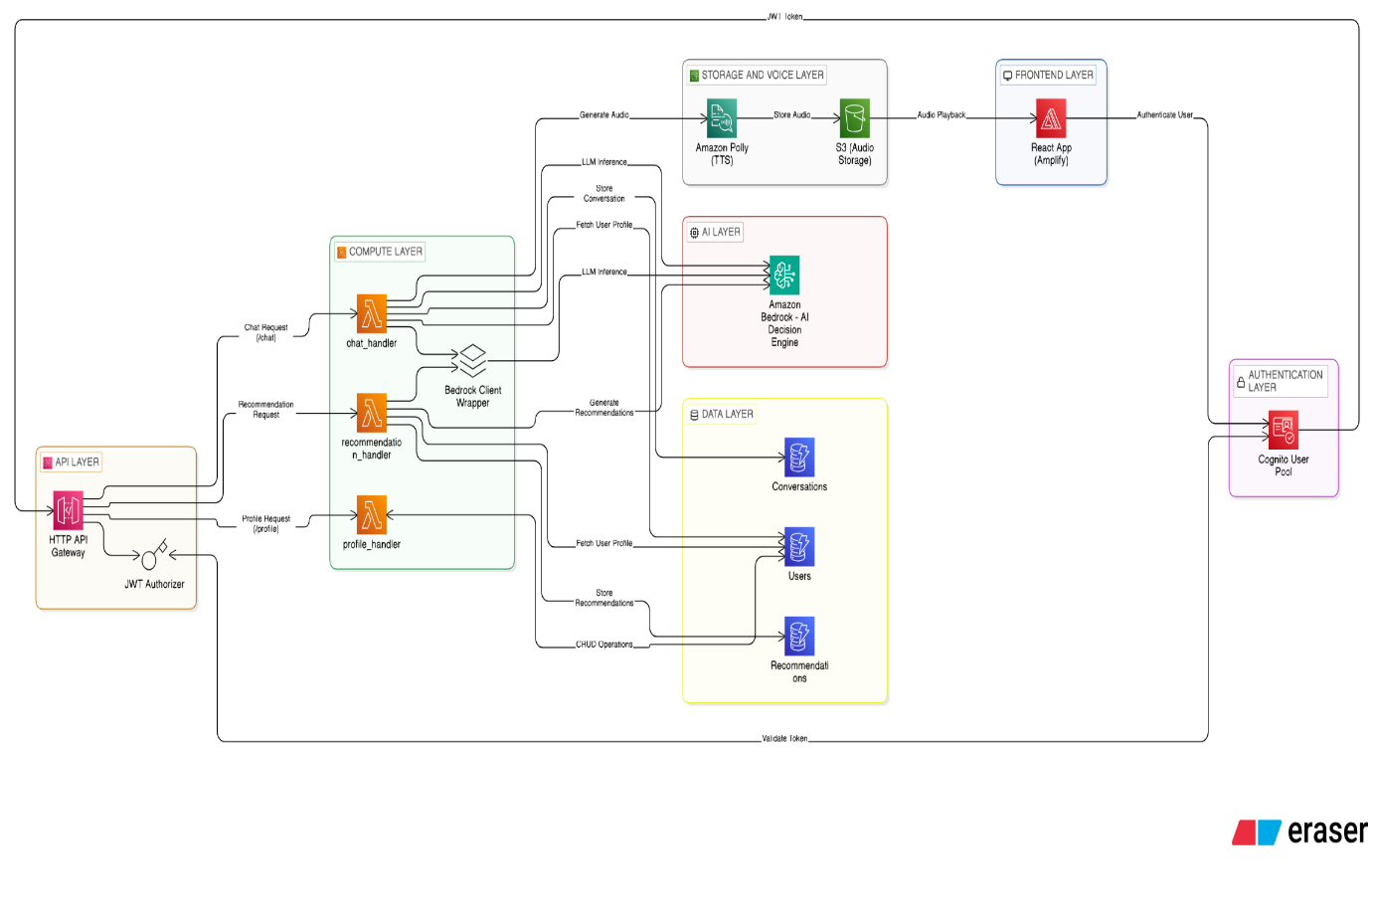
5.11 Testing and Evaluation
Tests were conducted to prove the effectiveness of the system. There were different tests conducted on the system, such as functional testing, integration testing, and performance testing.
Various inputs were used for testing the system to prove its efficiency. The results proved that the system performs consistently even when used repetitively.
Test Case ID | Description | Input | Expected Output | Result
TC01 | User Login | Valid credentials | Successful login | Pass
TC02 | Invalid Login | Wrong password | Error message | Pass
TC03 | Start Interview | User selects interview | Session starts | Pass
TC04 | Audio Response | User records audio | Transcript generated | Pass
TC05 | Feedback Generation | Submit response | AI feedback shown | Pass

From the user feedback, the system was found to be helpful in enhancing the communication skills and boosting confidence. The adaptive feature of the system was discovered to be quite successful in simulating an actual interview experience.
5.12 Conclusion
In this chapter, the implementation of the SkillRoute AI and the findings from the system tests were discussed. This section clearly illustrated how the system can provide real time interactions and personalized questions and feedback.
The use of cloud technology, AI, and modularity has made the system efficient and scalable. In the coming chapter, the conclusion for this entire project will be outlined.

CHAPTER 6
CONCLUSION

6.1 Summary of the Project
The main goal of this project is the creation of the intelligent system that will facilitate the preparation for interviews. The system SkillRoute AI is supposed to be the replacement for conventional techniques used by many candidates. The main problem with those approaches is that they lack adaptability, so a person cannot know how well he performs during the interview until he takes it.
The system consists of several interconnected elements, including speech recognition, natural language processing, and cloud-based services. The combination of those technologies allows the system to simulate the process of the interview and give the user instant feedback about his performance. Thus, the person will have the opportunity not only to improve his knowledge but also his skills of speaking and being confident.
This project shows how effective adaptive systems are. Contrary to conventional ones, adaptive systems adjust their behavior depending on performance and give a person a personalized experience rather than the same one for everyone.
6.2 Achievements
While creating the presented project, there were reached some major milestones. Specifically, a fully working platform was developed using web technology. It allowed users to communicate with the computer using its friendly interface.
At that, a proper integration of the frontend and the backend elements of the system ensured a good communication between them and allowed the processing of information in real time.
Moreover, the system managed to record answers in audio and text format, to process the provided information and generate feedback. Thus, the implementation of speech-to-text processing and answer analysis is reached successfully.
A very significant element of the project is the implementation of the adaptive decision-making mechanism, according to which a person is asked different questions depending on his/her performance.
The usage of cloud services allowed making the system scalable, while the database ensured the security and access to the user data.

6.3 Key Contributions
The project introduces many valuable contributions in terms of interview preparation systems. First, it introduces the use of behavioral analysis in conjunction with the conventional approach of response evaluation. In other words, in addition to assessing the accuracy of answers provided by users, the system takes into consideration such aspects as hesitation, timing of responses, and confidence levels.
Another contribution of the project lies in introducing a dynamic interaction mode. The system constantly monitors the user performance and changes its own behavior in response to this activity. Such approach ensures engagement and personalization.
The cloud architecture is another contribution that was introduced by the project. As can be seen from the analysis presented above, this architecture ensures the high performance and reliability of the system.
Finally, the project introduces an approach to fill the gap between theoretical knowledge and practice. Namely, the project helps users acquire certain skills that cannot be developed through conventional means.
6.4 Evaluation of the System
The effectiveness of the system was tested by examining how it manages user interactions, response management, and feedback generation. Test results show that there is no variation in performance in the different tests conducted. The system allowed interaction with users without any delays and gave accurate feedback to the users.
From the adaptive capacity of the system, it is evident that the method used is quite effective in ensuring user engagement. In the sense that it will depend on the performance, it prompts users to keep interacting in order to excel.
From the user's feedback, there is an improvement in communication skills and confidence among the users. The system gives users room to interact and learn over time.
6.5 Limitations of the System
However, there are some disadvantages in the system. The accuracy of speech processing is dependent on the quality of audio input. In an environment with noise, the effectiveness of the system might be compromised.
Another disadvantage is that the evaluation process is mostly dependent on predefined parameters. Despite the inclusion of behavioral analysis in the system, the accuracy of analysis can be improved.
The system also requires an uninterrupted internet connection since cloud-based services are involved. Disruptions in the internet connection may cause poor performance.
With all the disadvantages noted, there are ample opportunities for further development and improvement.
6.6 Conclusion
From this discussion, it can be concluded that the use of an adaptive AI system is a successful means of enhancing interview preparation. Through various technological components, SkillRoute AI is able to offer a dynamic learning process.
The system mitigates the flaws associated with conventional approaches to career training. With further modifications, it will prove to be a powerful career preparation tool..

CHAPTER 7
FUTURE SCOPE

7.1 Introduction
SkillRoute AI provides an effective platform for preparing for interviews, although there are still many ways to enhance the system further. In particular, one could improve accuracy and add new capabilities to help more people prepare for job interviews.
7.2 Advanced Behavioral Analysis
The introduction of advanced behavioral analysis methods is among the most obvious ways to enhance the platform further. Video analysis tools can be introduced into the application to evaluate not only speech but also other important parameters.
For example, one could assess eye movements, posture, and facial expressions. All these characteristics play a crucial role in interviews because non-verbal communication affects the result of an interview considerably.
7.3 Emotion Detection
Another key aspect that should be considered during future development is the introduction of emotion detection. Using specific algorithms, a user's state could be detected based on voice tone and the speech pattern.
This capability will allow providing personalized feedback depending on whether a user is nervous or confident.
7.4 Enhanced AI Models
In addition to the above-mentioned improvements, better AI models could also be used to enhance the quality of the system. Advanced AI models may come up with even more contextually meaningful questions, as well as give more accurate feedback about the quality of provided responses.
Continuous improvement will be achieved through training and collecting data.
7.5 Multilingual Capability
Currently, the platform only operates within a specific language. To make the platform more widely available to users, multilingual capability needs to be implemented.
As a result, people from different regions can conduct mock interviews using their native language.

7.6 Platform Integration with Online Courses and Learning Materials
In order to offer an even more useful product, the platform can be combined with the learning platform where users can find all kinds of learning materials. This would be convenient, as it allows combining everything in one location.
Additionally, users may get recommendations about learning resources depending on their current level of competence.
7.7 Career and Job Recommendation System
As an extra feature, the platform can be extended with a career recommendation service. Depending on users' preferences, interests, and achievements within the platform, appropriate career choices can be offered to them.
7.8 Mobile Application Development
Development of a mobile app for the platform will enhance its usability by making it convenient for the users to use whenever they want to do an interview practice exercise on their mobile devices.
A mobile application may provide functionalities such as notification reminders and tracking of progress among others.
7.9 Advanced Analytics Dashboard in Real-time
An analytics dashboard with real-time analytics could be considered for future versions of the platform. This will enable users to get an overview of their progress in areas such as areas of strengths, weaknesses, and improvements.
7.10 Conclusion
There are various areas in which SkillRoute AI platform has a wide scope for the future. Some areas are discussed above in terms of what can be done to make the platform more useful to its users.

REFERENCES
- Russell, S., & Norvig, P. (Artificial Intelligence: A Modern Approach)
- Jurafsky, D., & Martin, J. H. (Speech and Language Processing)
- AWS Documentation (https://aws.amazon.com)
- Research papers on AI-based interview systems
- Research papers on speech analysis and NLP
- Online resources related to conversational AI and machine learning

